### **Write the python program for Tic Tac Toe game**

### **AIM**

To implement a two-player Tic Tac Toe game in Python using a 3×3 board.

### **Algorithm**

1. Initialize a 3×3 board with empty spaces.
2. Define a function to display the board.
3. Define a function to check if a player has won by verifying:
   1. Any row has the same symbol.
   2. Any column has the same symbol.
   3. Either diagonal has the same symbol.
4. Alternate turns between Player X and Player O.
5. Ask the current player to enter row and column (0–2).
6. If the chosen cell is empty, place the symbol; otherwise, re-enter.
7. After each move, check for a winner.
   1. If a winner is found, display the board and announce the winner.
   2. If no winner after 9 moves, declare a draw.

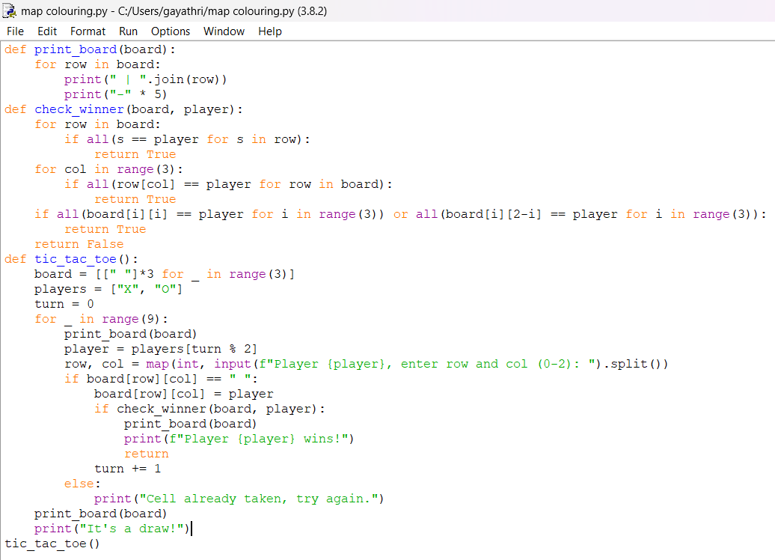

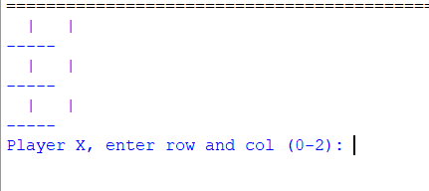

### **Result**

The program successfully simulates a two-player Tic Tac Toe game, allowing moves, checking winning conditions, and announcing the winner or a draw.